**Westridge Hills Owners Association, Inc.**

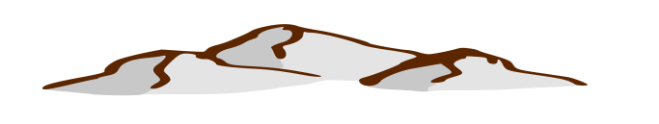

**55 Spring Park Trail,**

**Harpers Ferry, WV 25425**

[**www.westridgehillshoa.com**](http://www.westridgehillshoa.com)

**2019 Driveway Culvert Install Program**

**Lot Owner: _______________________________________**

**Address: __________________________________ _______**

**City _____________ State ____________ Zip ___________**

**Lot# ________________________**

**Options: (check choices) *Price includes sales tax and delivery***

**_____ 12 in. x 20 ft. Culvert HDPE Corrugated Pipe $112**

**_____ 15 in. x 20 ft. Culvert HDPE Corrugated Pipe $179**

**_____ Gravel to top cover driveway (just culvert installation spot) - $75**

**Culvert Specs:**

* **Manufactured with smooth interior allowing for more efficient flow**
* **Designed with a bell and spigot with a gasket for a water tight joint**
* **Excellent abrasion and corrosion resistance**
* **Long term drainage solution**
* **High Density Polyethylene**
* **Culverts are DOT approved. They will support the weight of any DOT approved vehicle when installed correctly. Meets or exceeds AASHTO M252 and AASHTO M294 Type S**

**Installation – Free by WHOA volunteers or you can purchase and install.**

**Payment by check to address above or online at** [**www.westridgehillshoa.com/payments/**](http://www.westridgehillshoa.com/payments/)

**What size to pick? Some areas (like on hills) have deep ditches will require larger size. The larger the size the less chance of clogging with leaves and debris. If you are in doubt of what size you need, give us a call – 304 607-2850.**